# Unveiling Market Insights: Analysing Spending Behaviour and Identifying Opportunities for Growth

**Define Problem / Problem Understanding**

**Specify the business problem**

Wholesaling or distributing is the sale of goods or [merchandise](https://en.wikipedia.org/wiki/Merchandising) to retailer to [industrial](https://en.wikipedia.org/wiki/Manufacturing), commercial, [institutional](https://en.wikipedia.org/wiki/Institutional) or other professional businessman to other wholesalers (wholesale businesses) and related subordinated services. In general, it is the sale of [goods](https://en.wikipedia.org/wiki/Good_(economics)) in [bulk](https://en.wikipedia.org/wiki/Bulk_sale) to anyone, either a person or an organization, other than the end consumer of that merchandise. Wholesaling is buying goods in bulk quantity, usually directly from the manufacturer or source, at a discounted rate. The retailer then sells the goods to the end consumer at a higher price making a profit.

## Requirements business

Analyzing spending behavior and identifying opportunities for growth can provide

crucial market insights for businesses looking to optimize their strategies and

increase market share.

Pricing Optimization: Analyze the relationship between pricing and spending

behavior to identify pricing strategies that maximize revenue while maintaining

customer satisfaction.

Purchase Patterns: Analyze the frequency and timing of customer purchases to

identify seasonal trends or patterns that can guide inventory management and

marketing campaigns.

Competitor Analysis: Compare your spending behavior data with competitors to

understand your market position, pricing strategies, and areas where you can gain a

competitive advantage

**literature survey :**

**social and business impact:**

* It shows the information about the data and shows the weak regions and channels and helps to improve the weakness and helps where to improve. By this the wholesaler makes plans to transport the goods and where to transport more goods. And what type of goods are selling more in which region and Personalization and Targeted Marketing: With insights from spending behavior analysis, businesses can personalize marketing efforts and promotions. This targeted marketing approach reduces unnecessary advertising noise and enhances the relevance of promotional messages for consumers.
* Economic Growth and Job Creation: As businesses identify growth opportunities and optimize their strategies, they often experience increased revenue and expansion. This can lead to economic growth and job creation, benefiting local communities and contributing to the overall prosperity.
* Revenue Growth: Leveraging market insights to identify growth opportunities can lead to increased sales and revenue for businesses. Understanding customer preferences and optimizing product offerings can attract more customers and improve customer retention.
* Cost Optimization: Data-driven decision-making allows businesses to allocate resources more efficiently. By identifying underperforming products or unprofitable channels, businesses can optimize costs and improve their bottom l

**data collection and extraction from datebase**

Data collection is the process of gathering and measuring information on variables of interest, in an established systematic fashion that enables one to answer stated research questions, test hypotheses, and evaluate outcomes and generate insights from the data

**Collection of dataset**

We have been collecting data fro various sources and examples of collecting data from various sources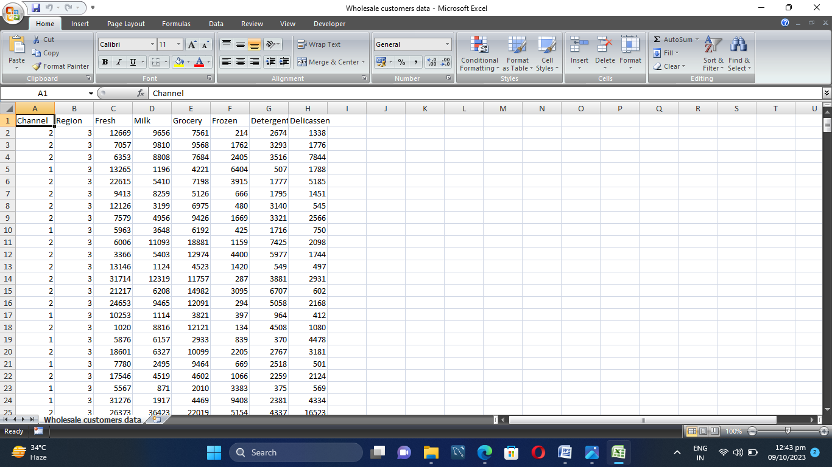

# 

# UNDERSTANDING THE DATA

Data contains all the meta information regarding the columns described in the CSV file. we have provided CSV file:

Wholesaler Customer Data.Csv

1.channel

2. region

3. fresh

4. milk

5 .grocery

6.frozen

7.detergents

**Connecting Dataset with tableau:**

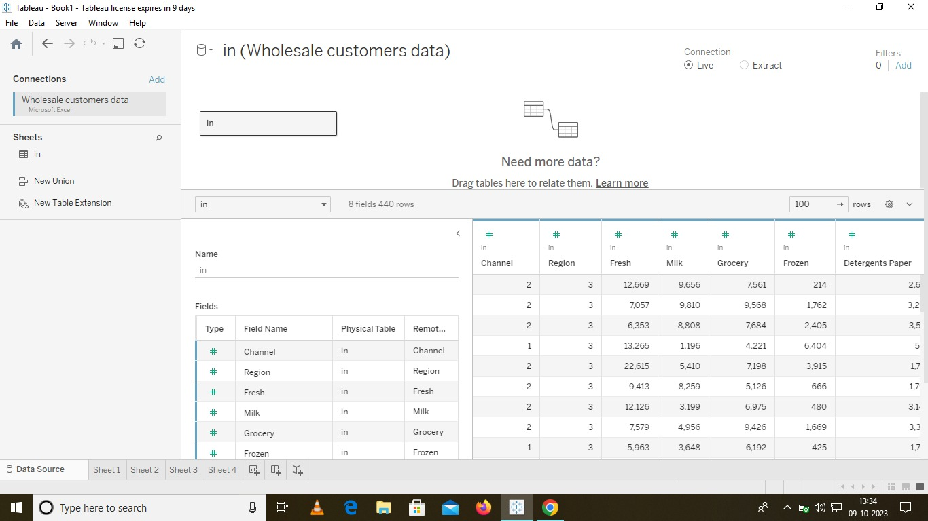

**Data Preparation**

Preparing the data for visualization involves cleaning the data to remove irrelevant or missing data, transforming the data into a format that can be easily visualized, exploring the data to identify patterns and trends, filtering the data to focus on specific subsets of data, preparing.

the data for visualization software, and ensuring the data is accurate and complete. This process helps to make the data easily understandable and ready for creating visualizations to gain insights into the performance and efficiency

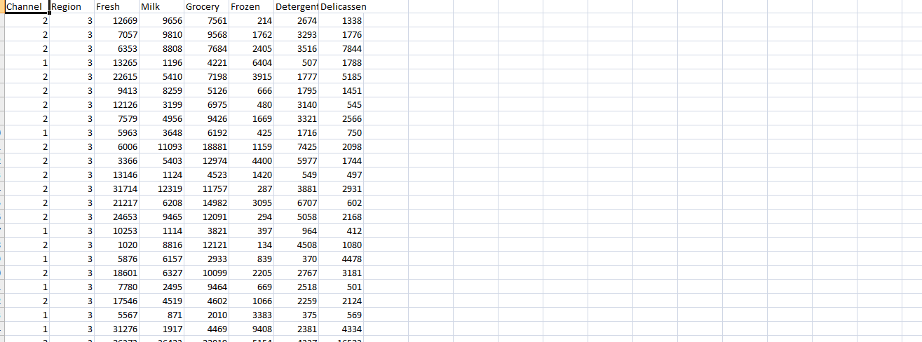

### Data Visualization

Data visualization is the process of creating graphical representations of data in order to help people understand and explore the information. The goal of data visualization is to make complex data sets more accessible, intuitive, and easier to interpret. By using visual elements such as charts, graphs, and maps, data visualizations can help people quickly identify patterns, trends, and outliers in the data.







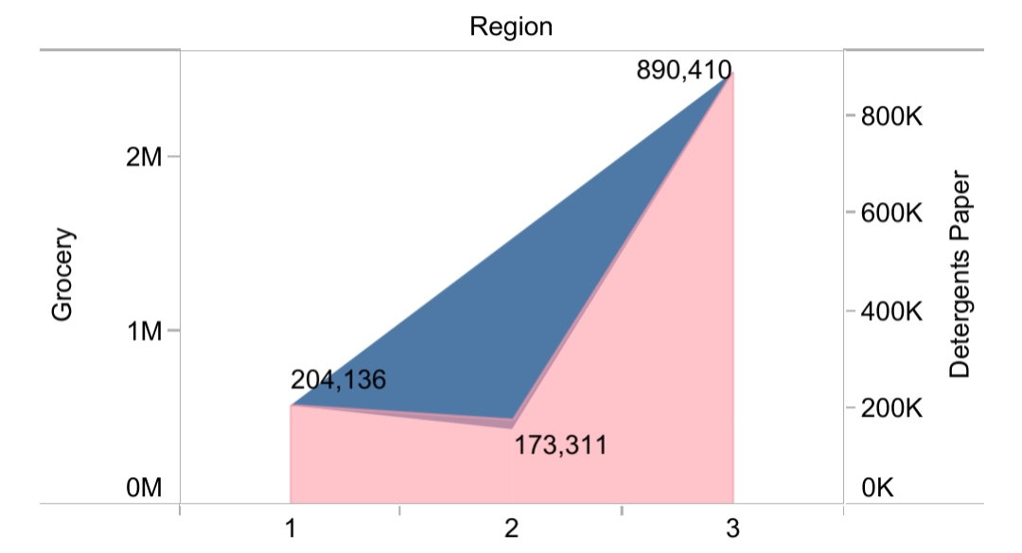

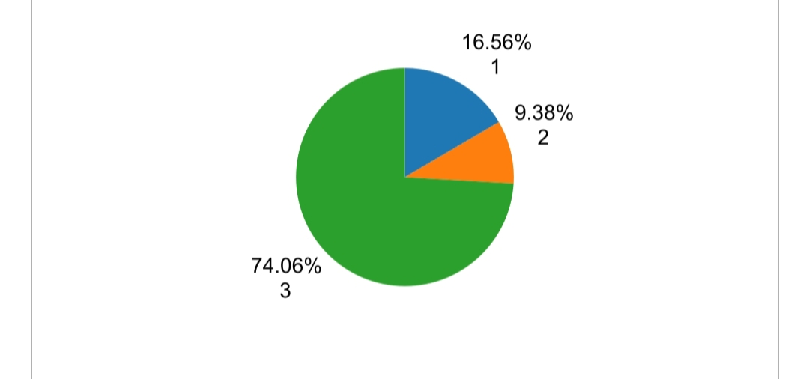

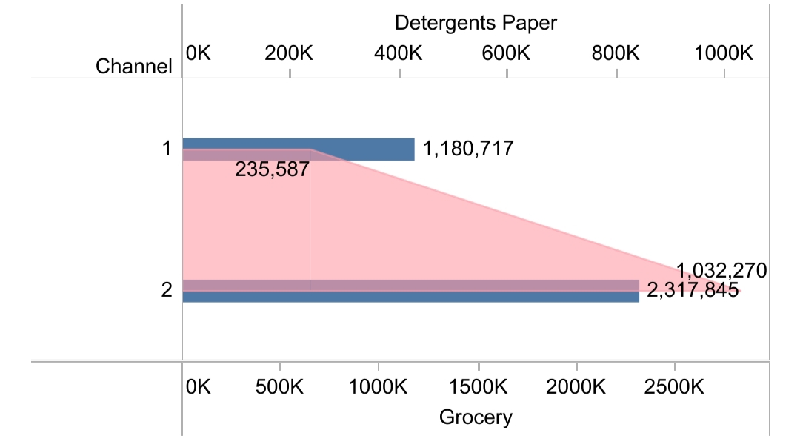

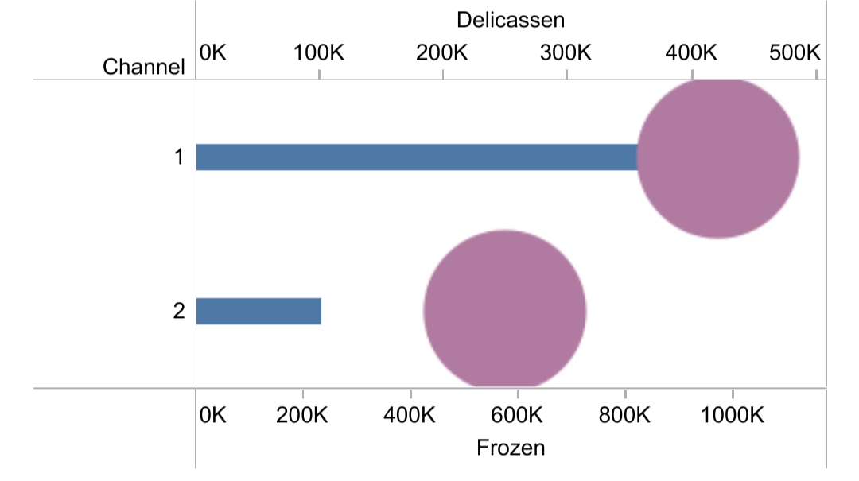

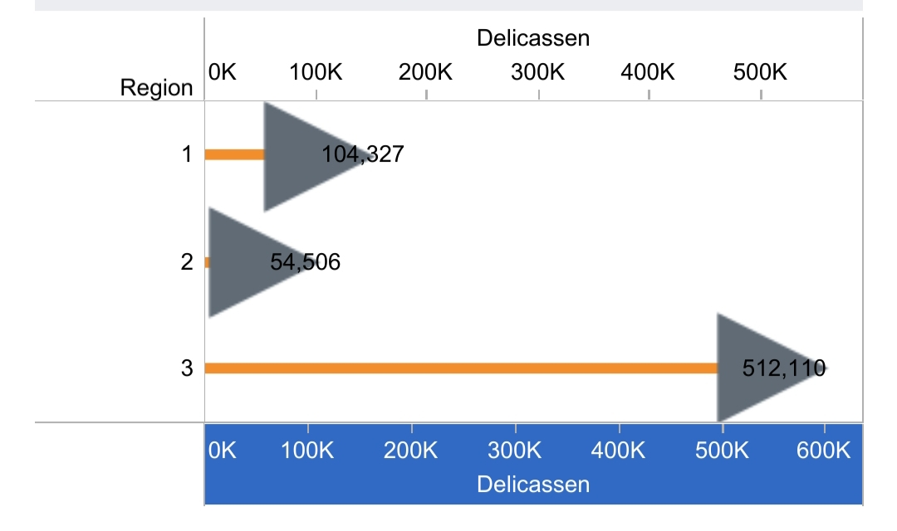

### Dashboard

A dashboard is a graphical user interface (GUI) that displays information and data in an organized, easy-to-read format. Dashboards are often used to provide real-time monitoring and analysis of data, and are typically designed for a specific purpose or use case. Dashboards can be used in a variety of settings, such as business, finance, manufacturing, healthcare, and many other industries. They can be used to track key performance indicators (KPIs), monitor performance metrics, and display data in the form of charts, graphs, and tables.

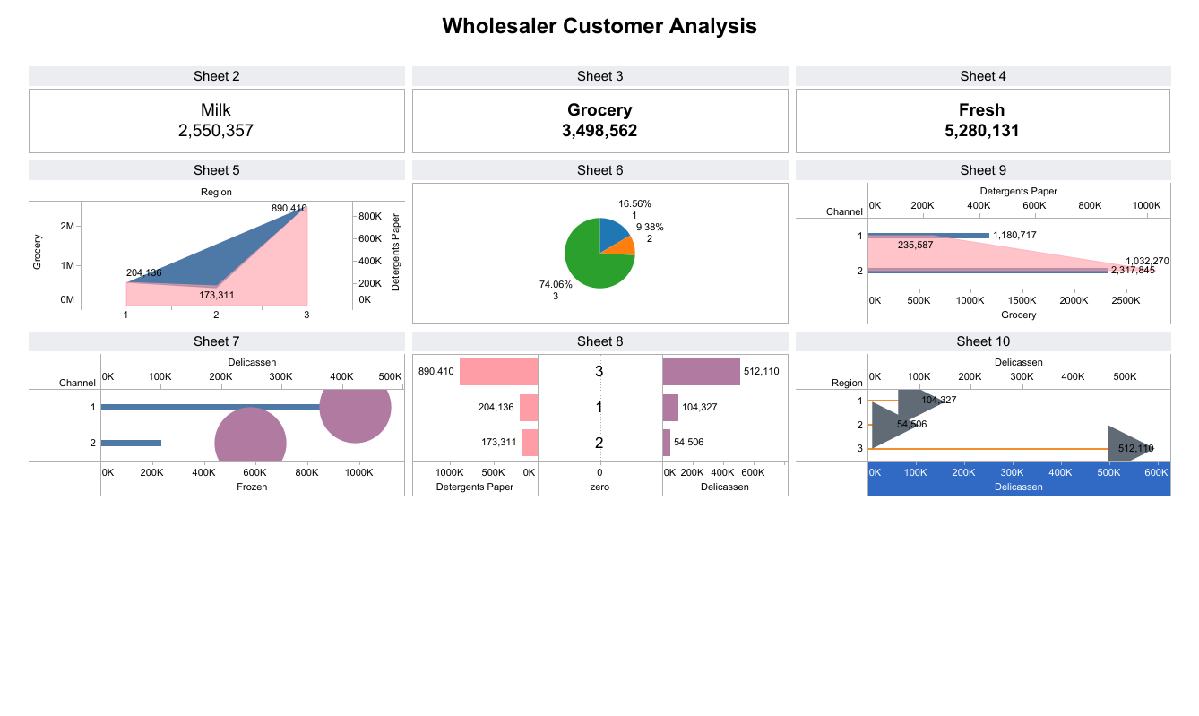

**Story**

A data story is a way of presenting data and analysis in a narrative format, with the goal of making the information more engaging and easier to understand. A data story typically includes a clear introduction that sets the stage and explains the context for the data, a body that presents the data and analysis in a logical and systematic way, and a conclusion that summarizes the key findings and highlights their implications. Data stories can be told using a variety of mediums, such as reports, presentations, interactive visualizations, and videos

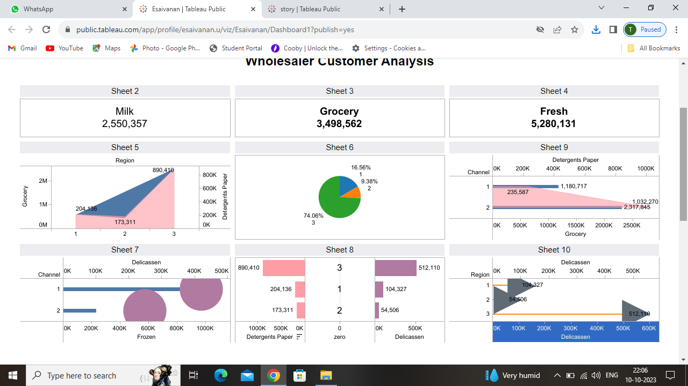

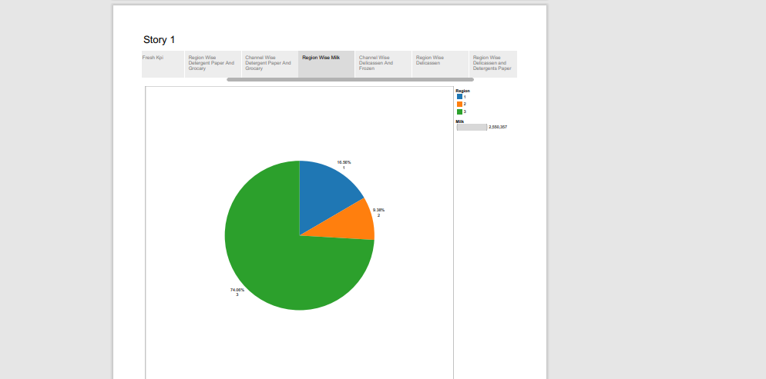

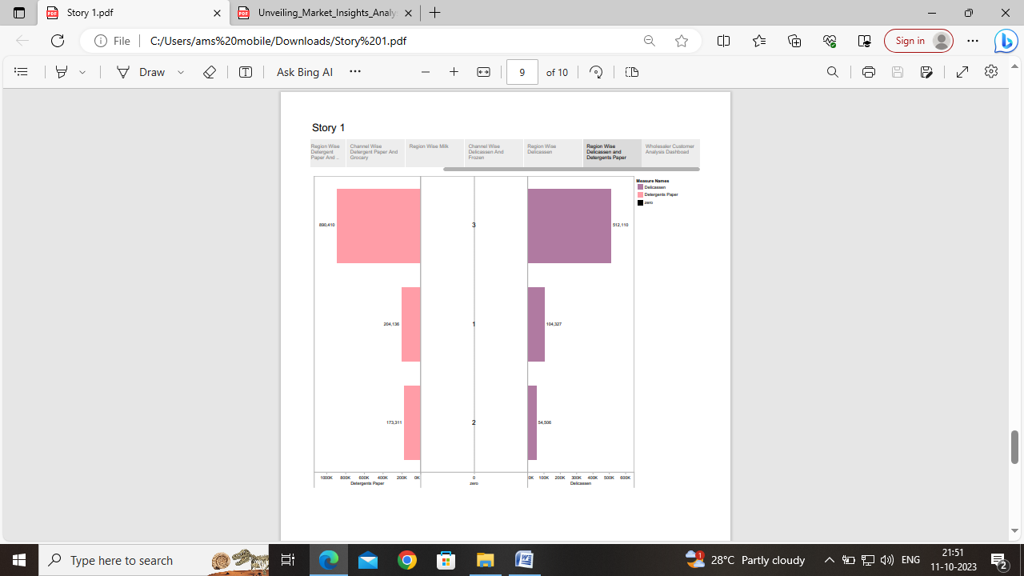

**NO.OF CALCULATIONS FIELDS**

# delicassen

# detergents paper

# fresh

#frozen

# grocery

# milk

# channel

# region

**No.of visualizations and graphs**

# KPI ­-3

# delicassen-1

# detergents paper-1

# fresh-1

#frozen-1

# grocery-1

# milk-1

# channel-1

# region-1

**Publishing**

**1. The tableau story link**

[**https://public.tableau.com/app/profile/esaivanan.u/viz/story_16969095620310/Story1?publish=yes**](https://public.tableau.com/app/profile/esaivanan.u/viz/story_16969095620310/Story1?publish=yes)

**2. The tableau dashboard link**

[**https://public.tableau.com/app/profile/esaivanan.u/viz/Esaivanan/Dashboard1**](https://public.tableau.com/app/profile/esaivanan.u/viz/Esaivanan/Dashboard1)

**The storyboard page**

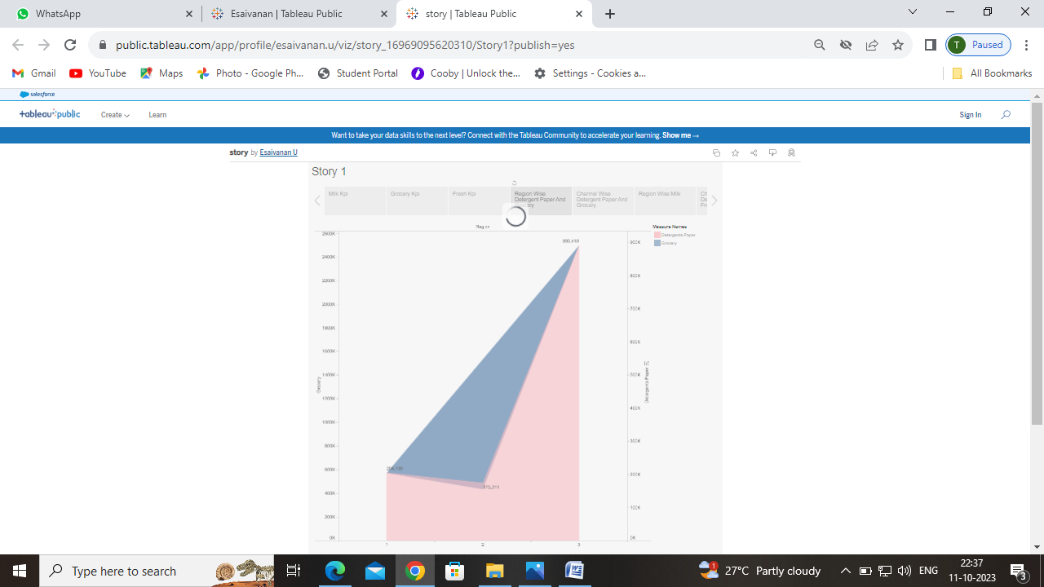

**The dashboard page**

